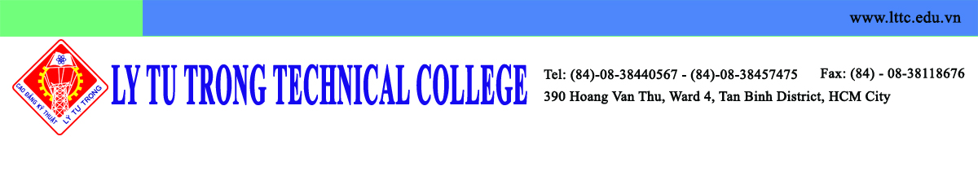
30 th June 2016
Dear Sanghak Yoon,

INVITATION LETTER

Ly Tu Trong Technical College of Ho Chi Minh City is pleased to invite a four member delegation led by Mr. Euigyn Na, the President of Kunsan National University, Republic of Korea, to visit our university from 6th to 7th July, 2016.
The members of the delegation
- Mr. Euigyn Na: Kunsan National University President.
- Mr. Dongik Kim: Business & Academic Cooperation Corps Director.
- Mr. Seman Pyo: Institute of International Affairs & Language Education Director.
- Mr. Sanghak Yoon: Exchange student program coordinator.

The delegation will meet with the President of LTTC, the administrators and sign the MOU to strengthen the mutual understanding. In addition, we will discuss the future co-operation between the two institutes. Regarding the expenses of the delegation, LTTC shall take care of the transportation within the country, meals and accommodation during the two day visit.
We are looking forward to see you at LTTC.
Sincerely Yours,

Pham Huu Loc
President of LTTC

